Problem Statement:
A health insurance company is seeking to enhance its understanding of operational performance by analyzing historical data related to policyholders, insurance policies, and claims. The goal is to identify key performance trends, improve customer segmentation, and make data-driven decisions for optimizing profitability and service quality.
Each dataset includes relevant fields such as:
Policyholders: policyholder_id, full_name, gender, date_of_birth, email, phone
Policies: policy_id, policyholder_id, policy_type, start_date, end_date, premium_amount, status
Claims: claim_id, policy_id, claim_date, claim_amount, claim_status, claim_type
Approach:
I queried data using SQL to understand patterns in profitability, customer segmentation, and claim performance. Key variables such as policy type, premium and claim amounts, claim status, and demographic attributes were analyzed.
Question:
1. Which policy type has the highest average claim amount?
SELECT
p.policy_type,
ROUND(AVG(c.claim_amount), 2) AS average_claim_amount
FROM policies p
JOIN claims c ON p.policy_id = c.policy_id
GROUP BY p.policy_type
ORDER BY average_claim_amount DESC;

2. What is the average premium collected and claim payout ratio per policy type?
SELECT
p.policy_type,
ROUND(AVG(p.premium_amount), 2) AS average_premium_amount,
ROUND(AVG(c.claim_amount), 2) AS average_claim_amount,
ROUND(AVG(c.claim_amount) / AVG(p.premium_amount), 2) AS claim_payout_ratio
FROM policies p
JOIN claims c ON p.policy_id = c.policy_id
GROUP BY p.policy_type;
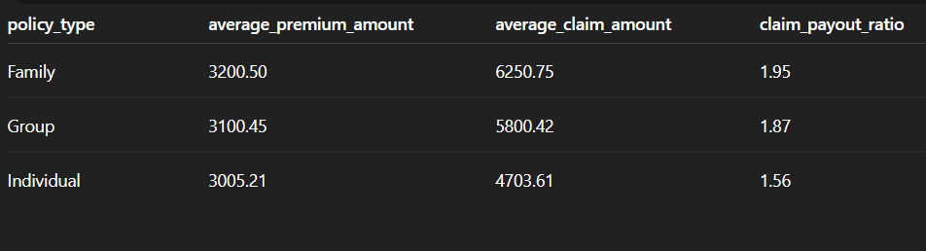
3. How many claims were rejected in the last 12 months, and what are the common types?

SELECT
c.claim_type,
COUNT(*) AS rejected_claims
FROM claims c
WHERE
c.claim_status = 'Rejected'
AND c.claim_date >= DATE_SUB(CURRENT_DATE, INTERVAL 1 YEAR)
GROUP BY c.claim_type
ORDER BY rejected_claims DESC;



4. Who are the top 10 policyholders with the highest total approved claims?

SELECT
ph.full_name,
ROUND(SUM(c.claim_amount), 2) AS total_approved_claims
FROM policyholders ph
JOIN policies p ON ph.policyholder_id = p.policyholder_id
JOIN claims c ON p.policy_id = c.policy_id
WHERE c.claim_status = 'Approved'
GROUP BY ph.full_name
ORDER BY total_approved_claims DESC
LIMIT 10;


5. How many policyholders are there by gender?

SELECT
gender,
COUNT(*) AS total_policyholders
FROM policyholders
GROUP BY gender
ORDER BY total_policyholders DESC;

6. How many policies are currently active?

SELECT
COUNT(*) AS active_policies
FROM policies
WHERE status = 'Active';

7. What is the claim approval rate (%) per claim type?

SELECT
claim_type,
ROUND(100 * SUM(CASE WHEN claim_status = 'Approved' THEN 1 ELSE 0 END) / COUNT(*), 2) AS claims_approval_rate
FROM claims
GROUP BY claim_type
ORDER BY claims_approval_rate DESC;

8. What is the total number of policies by each status?

SELECT
status,
COUNT(*) AS total_policies
FROM policies
GROUP BY status;

9. What is the average claim amount per claim type?

SELECT
claim_type,
ROUND(AVG(claim_amount), 2) AS avg_claim_amount
FROM claims
GROUP BY claim_type
ORDER BY avg_claim_amount DESC;

10. Which policyholders have multiple policies, and what is their total premium and claim amount?

SELECT
ph.full_name,
COUNT(DISTINCT p.policy_id) AS num_policies,
ROUND(SUM(p.premium_amount), 2) AS total_premium,
ROUND(SUM(IFNULL(c.claim_amount, 0)), 2) AS total_claim_amount
FROM policyholders ph
JOIN policies p ON ph.policyholder_id = p.policyholder_id
LEFT JOIN claims c ON p.policy_id = c.policy_id
GROUP BY ph.full_name
HAVING num_policies > 1;
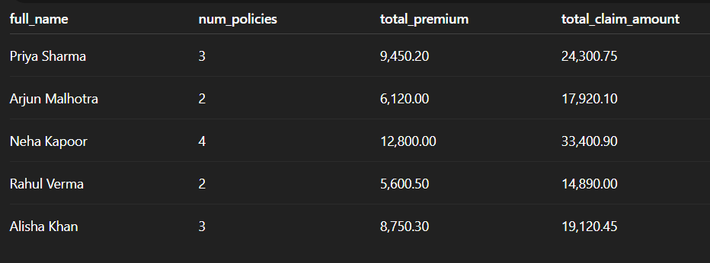

Impact
- Policy Type Profitability – Family policies show the highest claim burden with an average claim of $6,250.75 and payout ratio of 1.95, compared to Group (1.87) and Individual (1.56).
- Claims Management – A total of 75 claims was rejected in the past year, mainly from Hospitalization (30) and Surgery (25), signaling concentration in high-cost categories.
- High-Value Policyholders – The top policyholders received over $37,000 each in approved claims, with the highest at $48,725.30, showing heavy claim concentration among a few individuals.
- Demographics – The portfolio is nearly balanced, with 110 male and 90 female policyholders, offering an evenly distributed customer base.

Conclusion
Recommendations:
- Standardize documentation for claim types with high rejection rates.
- Automate routine claim evaluations to reduce pending cases.
- Segment customers by gender, age, or claim behavior for targeted campaigns.
- Introduce loyalty programs or bundled benefits for customer retention.

